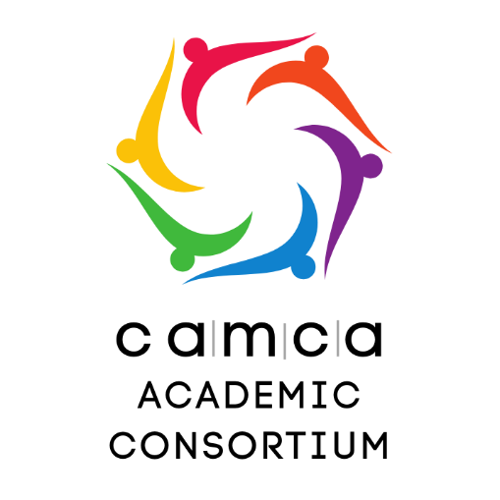
Memorandum of Understanding (MOU)
between CAMCA Academic Consortium and _______________________

Preamble
The CAMCA Academic Consortium and ________________________________ (hereafter referred to collectively as the "Parties") hereby enter into this MOU to establish a non-legally binding agreement on partnership and collaboration. The purpose of this MOU is to create a framework for cooperation and exchange of knowledge and expertise for the benefit of the wider CAMCA region in the areas of education, science, and technology promotion. This MOU is not intended to create any financial or legal obligations between the Parties.
The Parties agree to work together in good faith to achieve the objectives outlined herein. This MOU is subject to the laws and regulations governing the activities of the Parties, and it is not intended to conflict with any applicable laws or regulations.
Aims
The CAMCA Academic Consortium ("the Consortium") is a voluntary association of academic institutions and organizations from Central Asia, the Caucasus, Afghanistan, and Mongolia ("CAMCA region") established by the CAMCA Academy with the support of the CAMCA Network. The Consortium aims to promote cooperation among its members in the areas of education, science, and technology, and to contribute to the development of the CAMCA region.
Objectives
The objectives of the Consortium are:
- To encourage its members to engage in joint projects, programs, and activities related to education, science, and technology.
- To facilitate the exchange of information, knowledge, and best practices among its members.
- To promote collaboration and partnerships among its members, as well as with other institutions and organizations within and outside the CAMCA region.
- To enhance the quality and relevance of education, science, and technology in the CAMCA region.
Cooperation
The Consortium members agree to cooperate in the following areas:
- Joint projects, programs, and activities related to education, science, and technology, including research, innovation, and entrepreneurship.
- Exchange of faculty, students, researchers, and professionals among its members.
- Organization of joint conferences, workshops, and seminars on topics of mutual interest.
- Sharing of information, data, and resources related to education, science, and technology.
- Development of joint curricula, courses, and training programs.
- Promotion of public-private partnerships and engagement with industry, government, and civil society.
- Other areas of cooperation that may be agreed upon by the Consortium members.
Membership
Membership in the Consortium is open to academic institutions and organizations from and outside the CAMCA region that share its objectives and are committed to its activities.
Admission to the Consortium is subject to approval by its Steering Committee.
Governance
The Consortium is governed by a Working Group (Education), composed of representatives from the CAMCA Network.
The Working Group is responsible for the strategic direction, planning, and coordination of the Consortium's activities.
The Working Group may establish task forces or committees to address specific issues or projects.
The Consortium may hold an annual meeting, where its members can review progress, exchange information, and plan future activities.
Non-binding
This Memorandum of Understanding is non-binding and does not create any financially or legally binding obligations among its signatories.
This Memorandum of Understanding is effective as of the date of its signature and shall remain in effect until terminated by mutual agreement of the Consortium members.

Signatories
On behalf of CAMCA Academic Consortium | On behalf of ________________________
___________________________________  Executive Director  CAMCA Academy  CAMCA Academic Consortium  Date: | ___________________________________  Position  Organization  Country  Date:

